INDUSTRY-ORIENTED CUSTOMER BEHAVIOR ANALYSIS FOR BUSINESS DECISION MAKING

Submitted By
Name: Aarthi P

TOOLS USED:
* Python
* Pandas
* NumPy
* Matplotlib
* Seaborn
* Scikit-Learn
* Jupeter Notebook

ABSTRACT
Customer behavior analysis helps organizations understand customer preferences, retention patterns, and churn risks. This project uses data analytics and machine learning techniques to analyze customer data and generate insights that support business decision-making. The project focuses on identifying factors that influence customer churn and provides recommendations to improve customer retention and profitability.

PROBLEM STATEMENT
Companies collect large amounts of customer data but often fail to convert it into actionable business insights. Without proper analysis, organizations struggle to understand customer behavior, leading to customer loss and reduced revenue.

OBJECTIVES
1. Analyze customer demographics and behavior.
2. Identify churn patterns among customers.
3. Visualize important business trends.
4. Build a machine learning model for churn prediction.
5. Generate business recommendations based on data insights.

DATASET DESCRIPTION

Dataset Name: IBM Telco Customer Churn Dataset
Number of Records: 7043
Number of Attributes: 21
The dataset contains customer demographic information, service subscriptions,billing details and churn status.

SCREENSHOT 1- Import Libraries
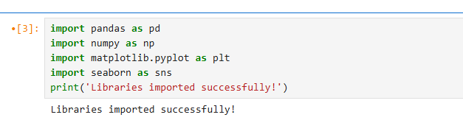
SCREENSHOT 2-Dataset Preview
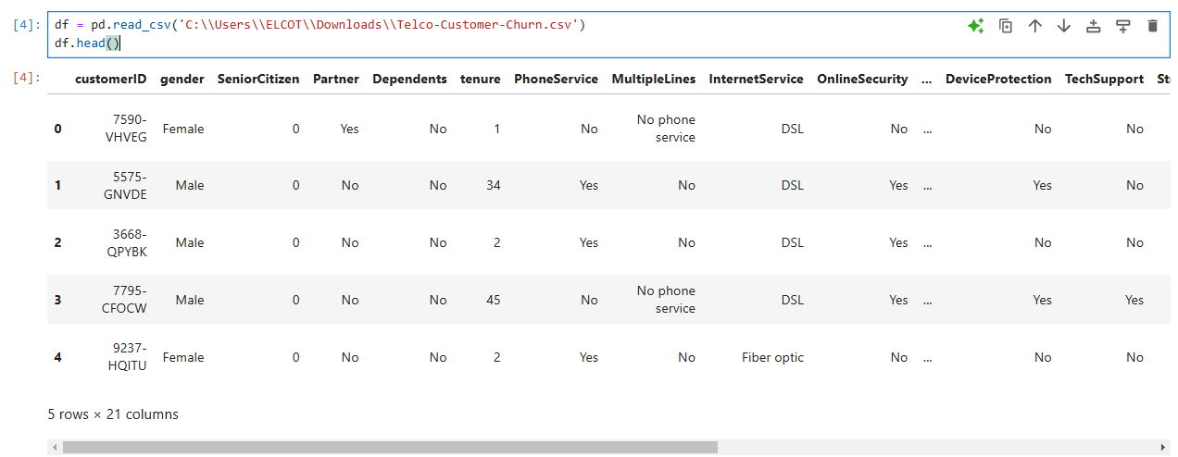

DATA PREPROCESSING
The following preprocessing activities were performed:
* Checked dataset dimensions.
* Verified data types.
* Checked missing values.
* Removed CustomerID column.
* Prepared data for analysis.

SCREENSHOT 3- Dataset Shape

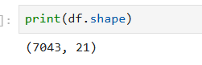

SCREENSHOT 4 – Dataset Information
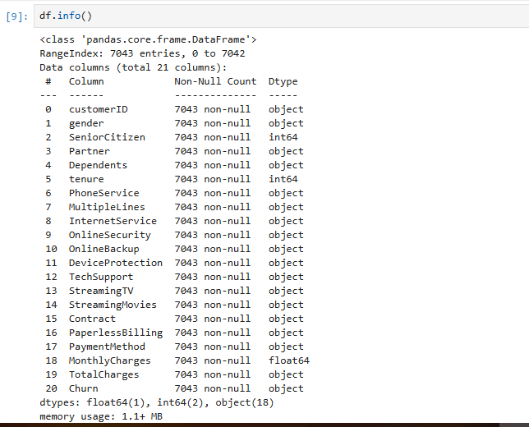
SCREENSHOT 5 – Missing Values
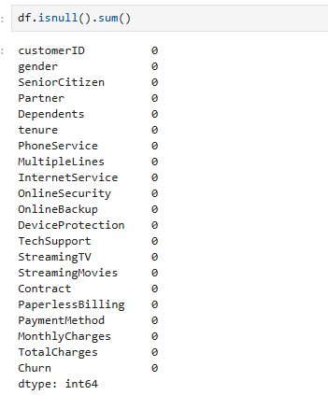
SCREENSHOT 6 – CustomerID Removal
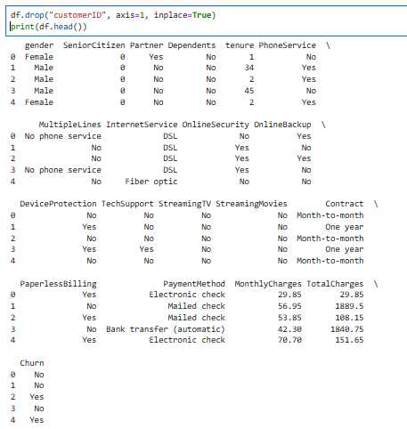
EXPLORATORY DATA ANALYSIS
Customer Churn Distribution
The churn distribution graph shows the proportion of customers who remained and those who left the company.
Observation:
Most customers remained with the company while a smaller percentage churned.
SCREENSHOT 7- Customer Churn Distribution
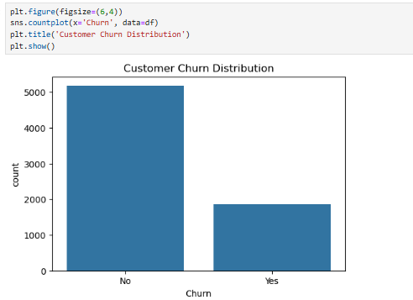
Churn Percentage Analysis
Observation:
Approximately 26% of customers left the company while 74% remained.
SCREENSHOT 8- Churn Percentage Analysis
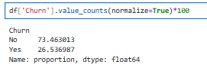
Gender vs Churn Analysis
Observation: Male and female customers exhibit similar churn patterns.
SCREENSHOT 9- Gender vs Churn Analysis
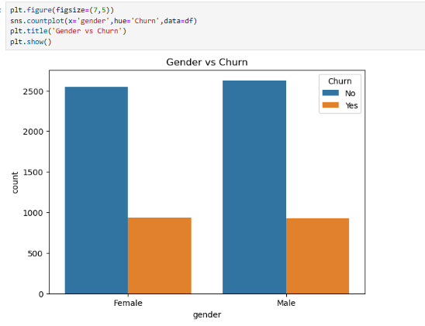Contract Type vs Churn
Observation: Customers with month-to-month contracts show the highest churn rate.
Screenshot 10- Contract Type vs Churn
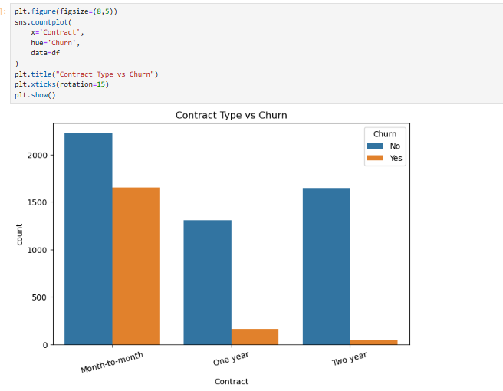
Internet Service vs Churn
Observation: Internet service type influences customer retention behavior.
SCREENSHOT 11- Internet Service vs Churn
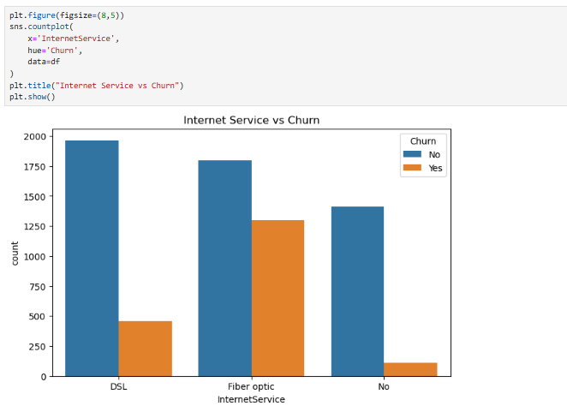
Monthly Charges Distribution
Observation: Customers paying higher monthly charges are more likely to churn.
Screenshot 12- Monthly Charges Distribution
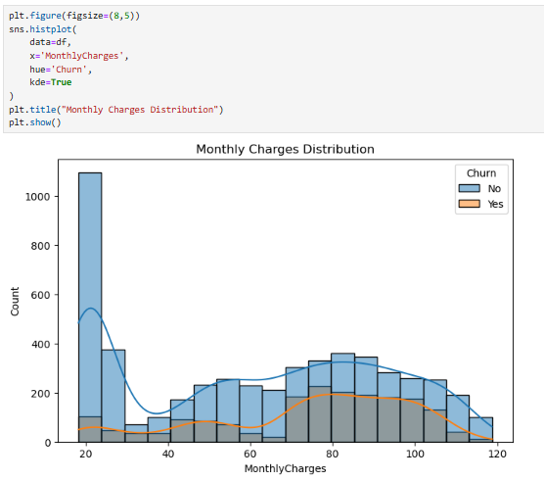
FEATURE ENGINEERING

The categorical variables were converted into numerical values using Label Encoding to prepare the dataset for machine learning.
SCREENSHOT 13-CONVERT TEXT TO NUMERIC
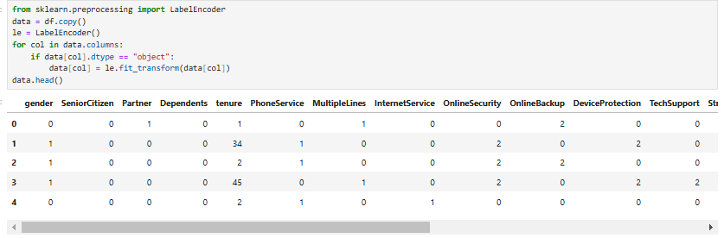
CORRELATION ANALYSIS
A correlation heatmap was generated to identify relationships between variables.

SCREENSHOT 14-CORRELATION HEATMAP
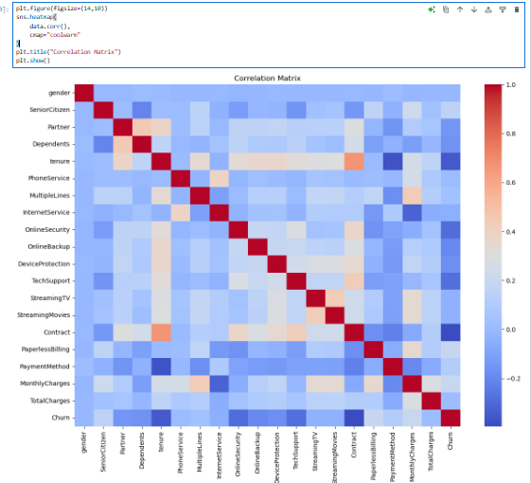

MACHINE LEARNING MODEL
Algorithm Used: Random Forest Classifier
The dataset was divided into training and testing sets using an 80:20 ratio.
SCREENSHOT 15-FEATURE SELECTION
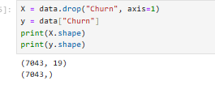
SCREENSHOT 16-TRAIN TEST SPLIT
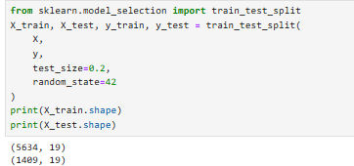
SCREENSHOT 17-TRAIN RANDOM FOREST MODEL
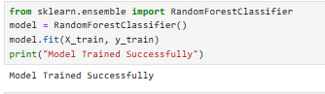
MODEL PREDICTION
Predictions were generated using the trained Random Forest model.
SCREENSHOT 18-MODEL PREDICTION
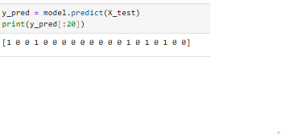
MODEL EVALUATION
Accuracy Score:0.7998580553584103
Observation: The Random Forest model achieved satisfactory performance in predicting customer churn.
SCREENSHOT 19-ACCURACY
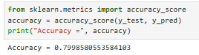

SCREENSHOT 20- CONFUTION MATRIX
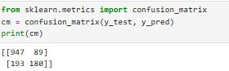

SCREENSHOT 21-CLASSIFICATION REPORT
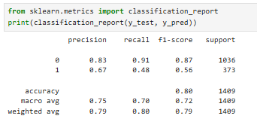

FEATURE IMPORTANCE ANALYSIS
Feature importance analysis identified the most influential variables affecting customer churn.
SCREENSHOT 22-FEATURE IMPORTANCE TABLE
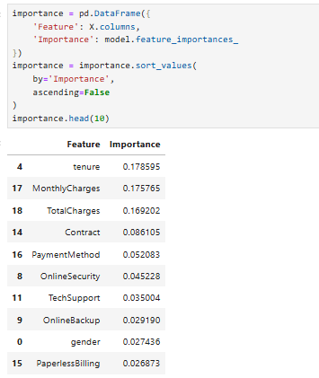
SCREENSHOT 23-FEATURE IMPORTANCE GRAPH
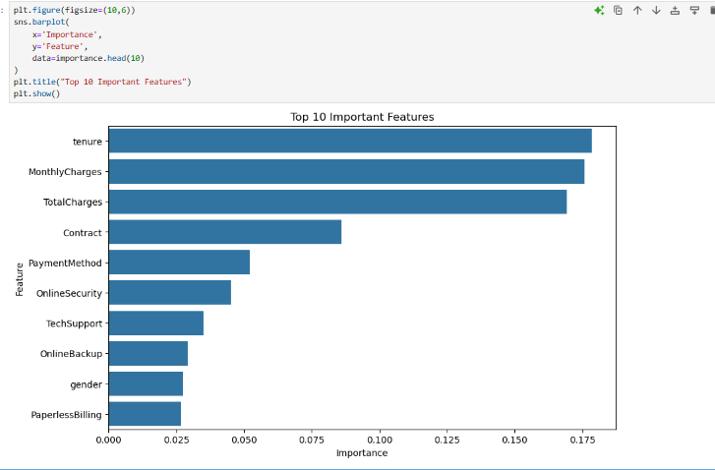
BUSINESS INSIGHTS
1. Customers with month-to-month contracts are more likely to leave.
2. Higher monthly charges increase churn probability.
3. Long-term customers demonstrate stronger loyalty.
4. Customer service and contract policies significantly impact retention.

BUSINESS RECOMMENDATIONS
1. Introduce discounts for annual and long-term contracts.
2. Implement loyalty programs for existing customers.
3. Provide personalized offers to high-risk customers.
4. Improve customer support services.
5. Develop retention campaigns targeting churn-prone customers.

CONCLUSION
This project successfully analyzed customer behavior using data analytics and machine learning techniques. The findings revealed important factors influencing customer churn and provided actionable business recommendations. The Random Forest model effectively predicted customer churn, demonstrating the value of data-driven decision-making in modern businesses.

FUTURE ENHANCEMENTS
1. Use larger real-world datasets.
2. Implement advanced machine learning algorithms.
3. Build interactive dashboards using Power BI or Tableau.
4. Deploy the model as a web application for real-time prediction.

